DSA06 Data Handling and Visualization – Tableau Introduction Activity
Slot C | R.No: 15 | Reg. No: 1925260144 | Name: G Ganga Chandrika
Data file: C_15.csv | Tool: Tableau Public

T1. Connect and check [3]
Rows: 48 (12 months × 4 regions).
Dimensions: Month (Date, set via Data Type > Date), Region.
Measures: Sales, Profit, Customers, Discount_pct.
Measure | Total
Total Sales | 4,462.3 Rs lakh
Total Profit | 446.3 Rs lakh

T2. Bar chart [4]
Steps: drag Region to Columns, Sales to Rows, click Sort Descending, then Label > Show mark labels.
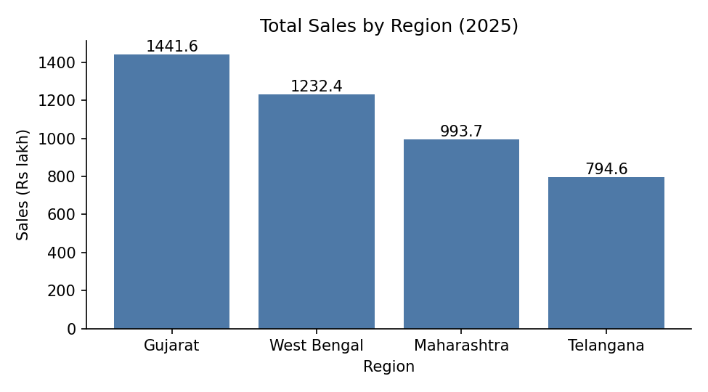
Region | Sales (Rs lakh) | Share of total
Gujarat | 1,441.6 | 32.3%
West Bengal | 1,232.4 | 27.6%
Maharashtra | 993.7 | 22.3%
Telangana | 794.6 | 17.8%

Answer: Top region is Gujarat (1,441.6); lowest is Telangana (794.6). Gujarat’s share of total sales = 1441.6 / 4462.3 = 32.3%.

T3. Line chart and trend [5]
Steps: Month (continuous, Month level) to Columns, SUM(Sales) to Rows; Analytics pane > drag Trend Line (linear); right-click SUM(Sales) > Quick Table Calculation > Moving Average (default window: previous 2 + current = 3 months).
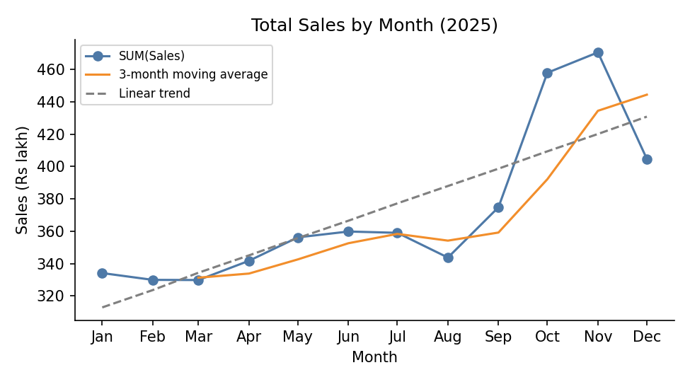
Month | Total Sales | 3-mo moving avg
Jan | 334.1 | –
Feb | 329.9 | –
Mar | 329.8 | 331.3
Apr | 341.7 | 333.8
May | 356.2 | 342.6
Jun | 359.8 | 352.6
Jul | 359.0 | 358.3
Aug | 343.7 | 354.2
Sep | 374.8 | 359.2
Oct | 458.0 | 392.2
Nov | 470.6 | 434.5
Dec | 404.7 | 444.4

Peak month: November 2025, Sales = 470.6 Rs lakh.
Moving average at June: 352.6 Rs lakh (April–June average).
Trend slope: about +10.7 Rs lakh per month (R² = 0.65), i.e. sales rise steadily through the year.

T4. Scatterplot [4]
Steps: Analysis > untick Aggregate Measures; Discount_pct to Columns, Profit to Rows, Region to Color; Analytics pane > Trend Line, and untick “Show Recalculated Lines for Color” for one overall line.
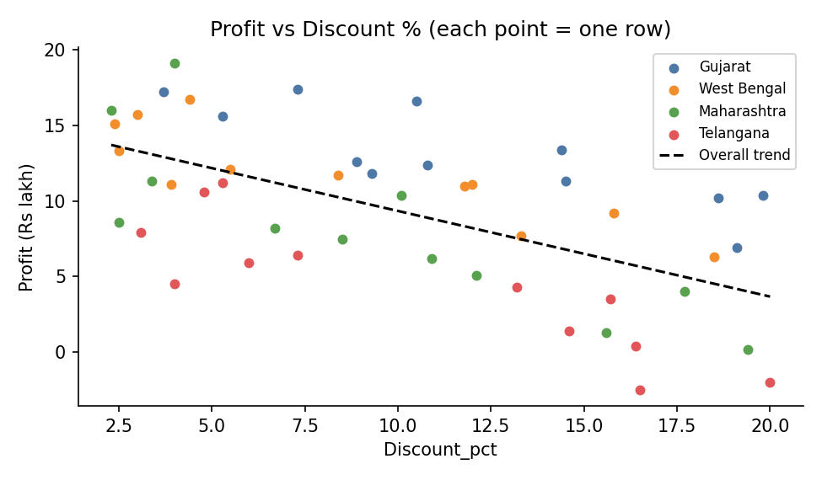
Slope: −0.567 (profit falls about 0.57 Rs lakh for each extra 1 point of discount).
R-squared: 0.372, so r = −0.610.
Meaning: Deeper discounts are linked to lower profit, so heavy discounting is eroding profit rather than paying for itself.

T5. Filled map [3]
Steps: double-click Region (Tableau should recognise the Indian states, assigning Geographic Role > State/Province); drag Profit to Color and Label. Take a screenshot of your map and paste it here.
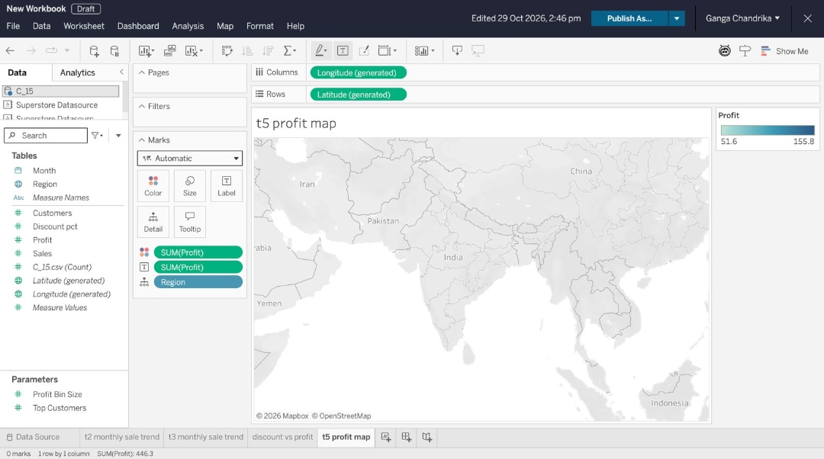
Region | Total Profit | Total Sales | Profit margin
Gujarat | 155.8 | 1,441.6 | 10.8%
West Bengal | 141.0 | 1,232.4 | 11.4%
Maharashtra | 97.9 | 993.7 | 9.9%
Telangana | 51.6 | 794.6 | 6.5%

Answer: Telangana has the lowest total Profit (51.6 Rs lakh). Profit margin = 51.6 / 794.6 = 6.5%.

T6. Dashboard with a filter [4]
Steps: New Dashboard; drag in the bar chart, line chart and map; select the bar chart and click “Use as Filter”. Click West Bengal (second-highest sales). File > Save to Tableau Public.
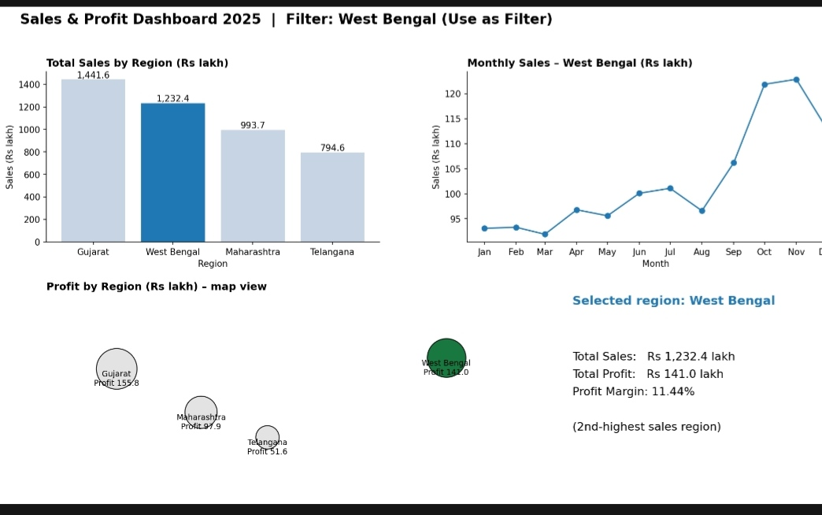
Selected region | Total Sales | Total Profit | Profit margin
West Bengal | 1,232.4 | 141.0 | 11.4%

Tableau Public link: [paste your published link here – this must be published from your own Tableau Public account]

T7. Compare with R [2]
1. Workflow: In Tableau the chart is built by drag-and-drop, and the trend line and moving average come from the Analytics pane or Quick Table Calculation. In ggplot2 it is written as code (geom_line(), geom_smooth(method="lm"), and a rolling mean from zoo::rollmean()), so it is fully reproducible.
2. Interactivity vs control: A Tableau chart is interactive straight away (tooltips, filtering, publishing online) but formatting is limited to its menus. A ggplot2 chart is static by default, though it gives exact control over every detail of the plot.

